The Lightweight IBM Cloud Garage Method for Data Science

Architectural Decisions Document Template

# Architectural Components Overview

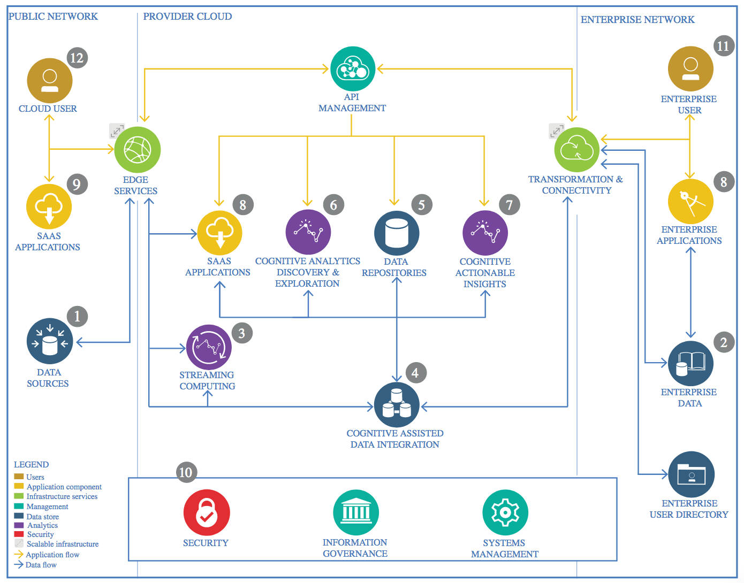

IBM Data and Analytics Reference Architecture. Source: IBM Corporation

## Data Source

### Technology Choice

I used Anaconda Prompt/Jupyter notebook to create the following project.

### Justification

It’s one of the most basic and easy to use environments out there for python. Since Watson studio gives it a more professional/premium look, it has a limit. Hence I first made the notebook in Jupyter and then re-uploaded using Watson Studio.

## Enterprise Data

### Technology Choice

Watson Studio

### Justification

One of the free and high environments out there.

## Streaming analytics

### Technology Choice

Microsoft Azure

### Justification

Please justify your technology choices here.

## Data Integration

### Technology Choice

ETL.

### Justification

N/A

## Data Repository

### Technology Choice

Github/Watson Studio.

### Justification

They are mainstream.

## Discovery and Exploration

### Technology Choice

Google

### Justification

It’s the best search engine.

## Actionable Insights

### Technology Choice

N/A

### Justification

N/A

## Applications / Data Products

### Technology Choice

Microsoft

### Justification

It’s the best.

## Security, Information Governance and Systems Management

### Technology Choice

N/A

### Justification

N/A